Medical Device Recall

HeartSine® samaritan® PAD
Pad-Pak-03, -03J, -04, -04J & -07
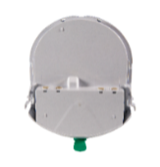
Attn: AED Program Manager/Safety Manager
Recall: PR 4068245 (FA327)
10/10/2025

This urgent medical device voluntary recall is being issued to alert customers with Pad-Paks that have expiry date between April 17, 2025 – August 1, 2029, of a potential bent locator pin issue, and to provide instructions to ensure the Pad-Pak is properly inserted into the SAM PAD device.

Product description Both the Adult and Pediatric Pad-Pak accessories to the HeartSine samaritan PAD device contain the battery to power the AED, and two electrode pads to provide the electrical connection to the patient’s chest for delivery of defibrillation shock.

Product issue Post-market surveillance has revealed that the Pad-Paks are not always inserted properly into the HeartSine samaritan PAD devices as outlined in the IFU, which can create failure during device use. In the event the device is unable to complete connection, the device will repeatedly prompt “Apply Pads to patient’s bare chest”. In some cases, the AED device may fail to power on entirely.

Upon investigation, two potential causes of the improper insertion of Pad-Paks include use error and bent locator pins, which may occur during the manufacturing process.

Potential risks The connection issues that may arise from improper insertion of the Pad-Pak are not always obvious to the user when the Pad-Pak is inserted into the HeartSine samaritan PAD device. If the Pad-Pak is not properly inserted into the HeartSine samaritan PAD device, or if the Pad-Pak locator pins are bent, the device may fail to deliver the intended therapy during use, potentially leading to a delay in treatment or no treatment being delivered during use. A delay in treatment or no treatment may result in serious injury or death.

Complaint information Since 2018, 120 complaints were reported among more than 1,447,266 Pad-Paks in service worldwide. Of these, there have been 36 adverse events of which five were confirmed to be caused by bent locator pins, two devices were not returned for investigation and 29 were determined to be related to potential use error.

Customer actions needed:
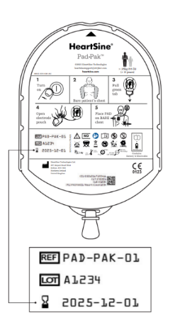
To ensure the device works correctly in an emergency, follow the instructions below to ensure that the Pad-Pak is securely and correctly installed. No qualification is required to perform this test.

- Check the expiry date on your Pad-Pak:
The expiry date can be found on the rear of the Pad-Pak
(see diagram at right or refer to section “Set up your AED” in the IFU).
  - If your Pad-Pak expires between April 17, 2025 – August 1, 2029
proceed to step B below.

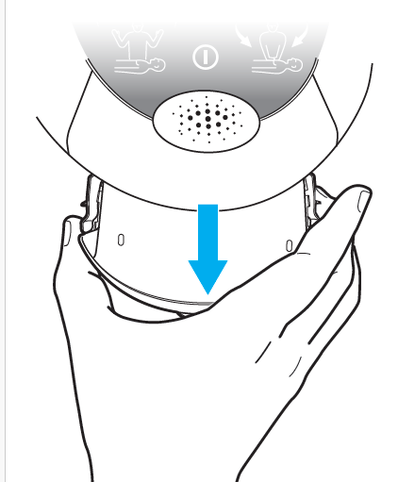
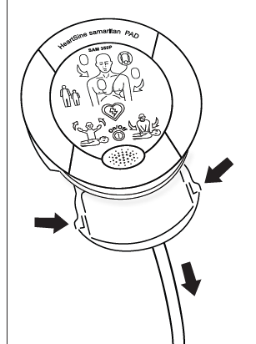
- Check for bent locator pins:
  - Place the HeartSine SAM PAD face up on
a table or other flat surface.
  - Squeeze the tab on each side of the Pad-Pak
as shown on the right.
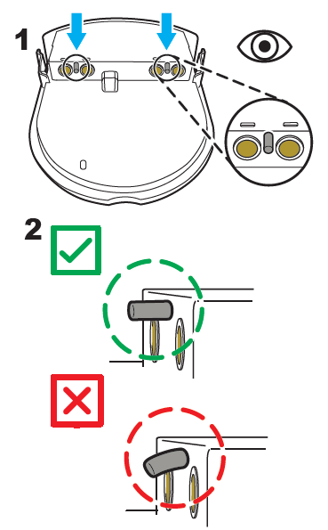
  - Pull to remove the Pad-Pak from the device.
  - Once the Pad-Pak is removed from the device
check the locator pins (blue arrows in Step 1 at the right)
to ensure they are straight and not bent, as shown
in step 2 at the right.
- If locator pins are straight, proceed
to Step C below to follow Pad-Pak insertion
instructions.
- If pins are bent:
  - Remove that Pad-Pak from your device,
and set it aside. Pull another Pad-Pak from your
inventory, verify locator pins are straight,
then proceed to Step C below, to properly
insert the Pad-Pak into the device.
  - If you do not have an additional Pad-Pak in
your inventory, remove the device from service
and proceed to Step D below.
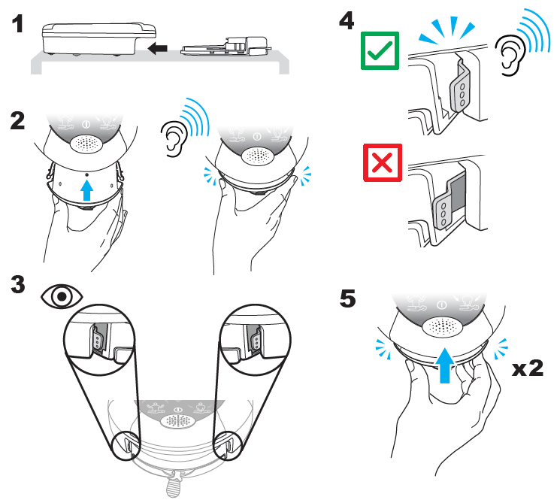
- Follow Pad-Pak insertion instructions:

Illustration 1: Place your HeartSine SAM PAD
and the Pad-Pak face up on a table or other
flat surface.
Illustration 2: Slide the Pad-Pak into bottom of the AED as shown until you hear the “double click” and
look at both clips to ensure they are correctly engaged.

Illustration 3: Look at both clips to ensure they are correctly engaged.

Illustration 4: Correctly engaged clips will click in and sit snugly/tightly against the AED with no gap as per the green tick. Incorrectly engaged clips will not click and will have a gap as shown in the image with the red x.

Illustration 5: Push the Pad-Pak in one last time to ensure correct engagement. Once you’ve verified proper insertion, return the device to its storage location for use.

Proceed to Step D / Step F – submit your response.

D. Submit your response:
Submit your response by completing the Appendix A - Response Form and submit via email to: info@euroenergy.co.uk

- Maintain awareness: Maintain awareness of this communication internally and near the affected unit until all required actions have been completed within your facility.

- If you have further distributed affected product(s), please forward a copy of this notice to the new responsible party and email info@euroenergy.co.uk with both the location to which the product(s) was/were further distributed to and the quantity and lot number for any Pad-Paks that have been disposed of.

Stryker’s planned action:
Stryker and distribution partners are notifying all customers who have received affected Pad-Paks to perform the actions outlined above by 28/Nov/2025. On behalf of Stryker and Euro Energy Resources Limited, we thank you sincerely for your response and regret any inconvenience this may have caused.

If you have any questions or concerns, please contact info@euroenergy.co.uk or 0116 234 0567

In line with the recommendations of the Medical Device Coordination Group Guidance document Ref MDCG 2023-3 and EU MDR 2017/745, we can confirm that this FSCA has been notified appropriately to the National Competent Authority for your country.

Appendix A

Business Reply Form
Business reply form

HeartSine® samaritan® PAD
Pad-Pak-03, -03J, -04, -04J & -07

Recall Number: PR 4068245 (FA327)
10/10/2025

Response to this Notification is required. Please complete and sign this form.
Email the completed form to info@euroenergy.co.uk by 10/11/2025.

Account number: ______________________________
Company name____________________________________________________________
Company address: _____________________________________________________________________________

- # of Pad-Paks with bent pins, catalog number and lot: * __________________________________________________________________________________________________________________________________________________________________________________________________________________________________________________________________________________________________________________________________________________________________

- Total number of Pad-Paks verified & properly inserted into the SAM PAD: ________________
- Have you distributed any Pad-Paks outside of your organization?
___ Yes * ___ No

* Follow the instructions from the main letter Step F. Your main distributor/contact person will be in contact with you to discuss next step.
By signing & submitting this form, I acknowledge receipt of the medical device recall letter, agree I have provided accurate information, and approve my responses.

Form completed by:
Printed name |  | Title
Signature |  | Phone
Date |  | Email

